[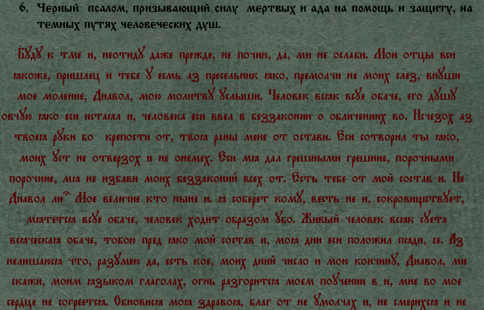](http://img30.imageshack.us/i/58962057.png/)[](http://img30.imageshack.us/i/12235325.png/)